Prototypes

Homepage/Landing Page

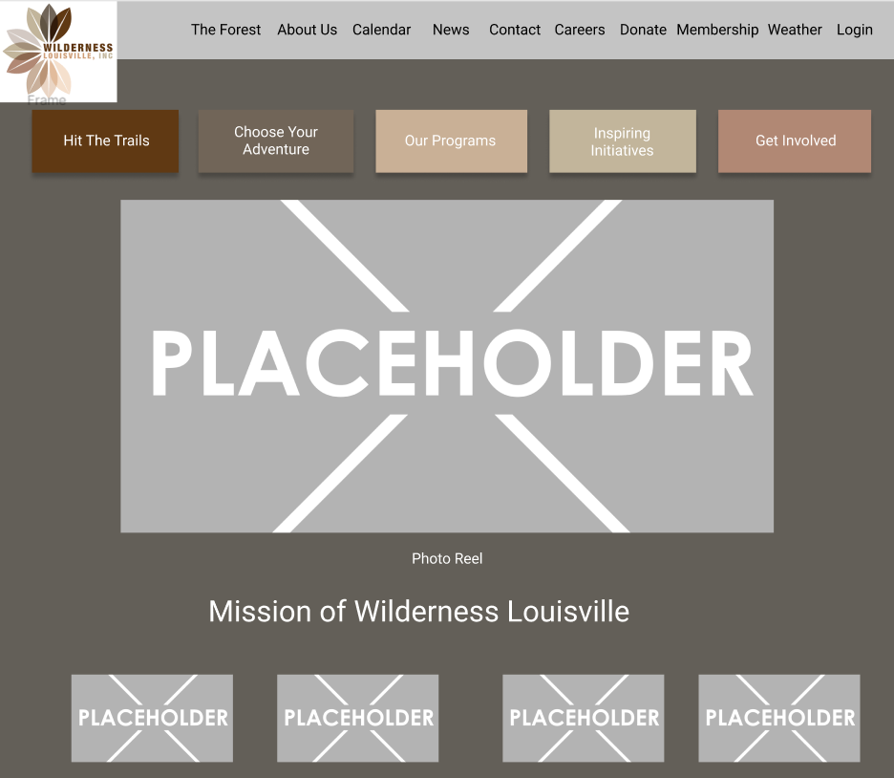

Hit the Trails Page

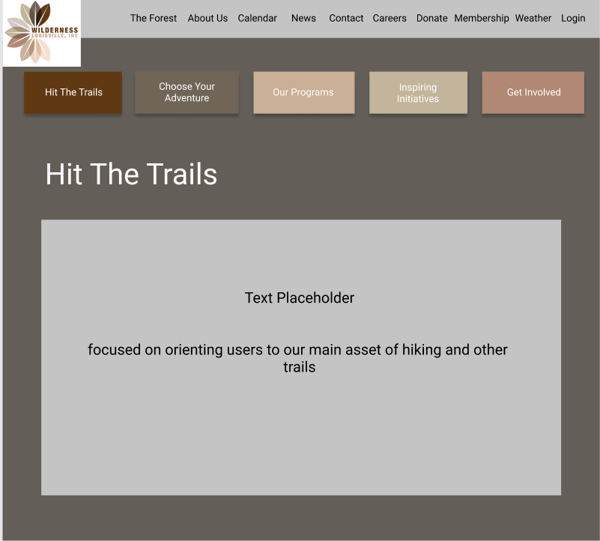

Choose Your Adventure Page

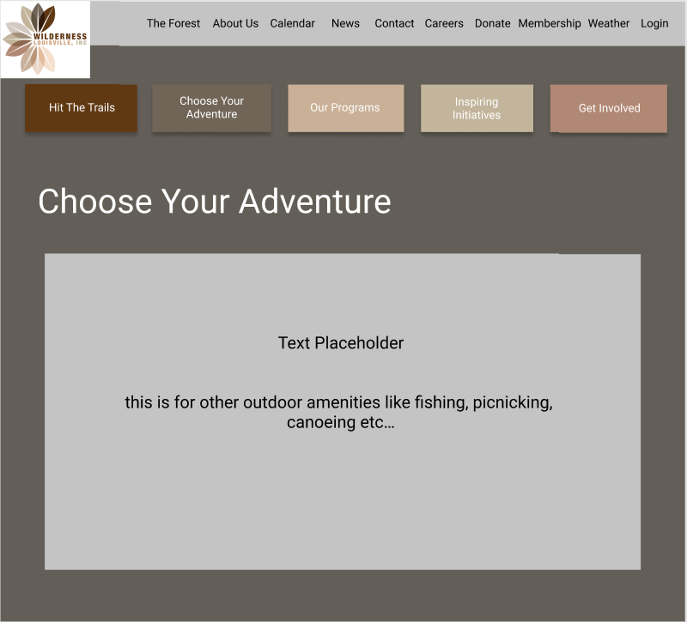

Programs/Events Page

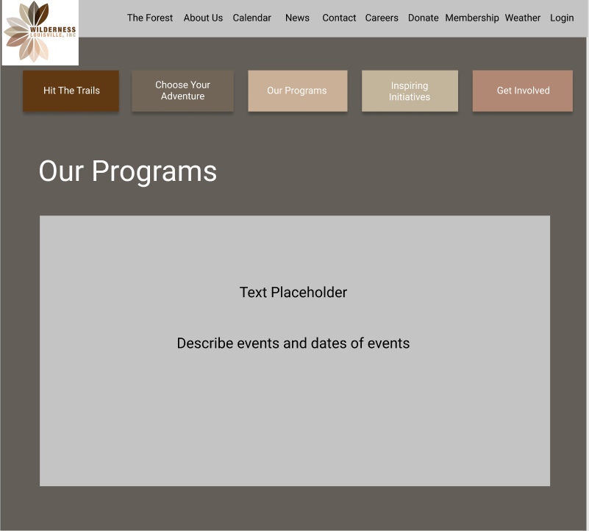

Get Involved

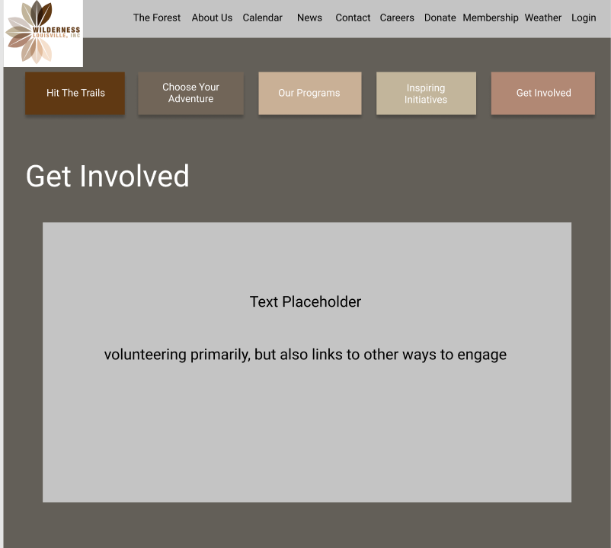

The Forest/Natural Areas Page

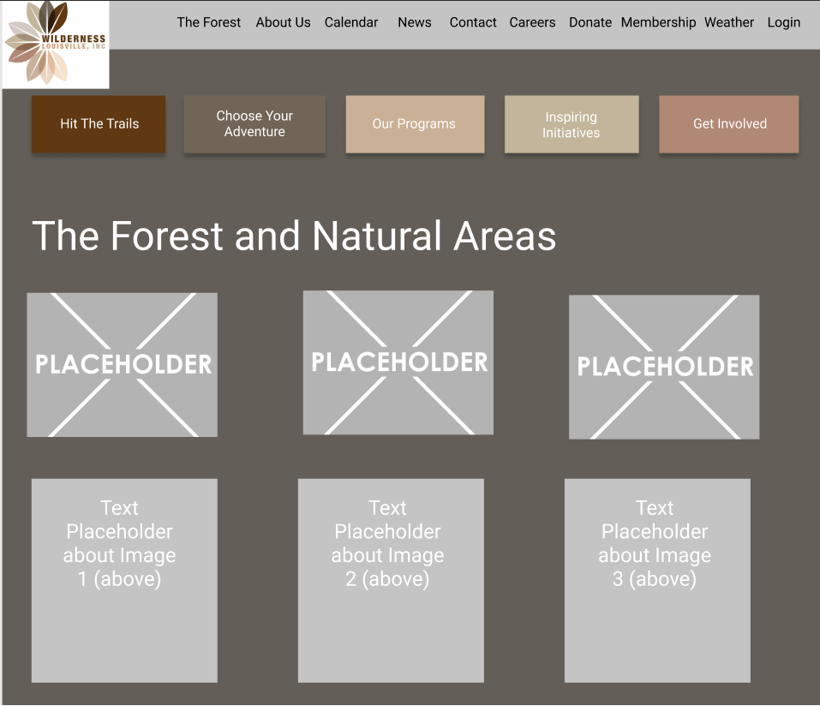

About Us Page

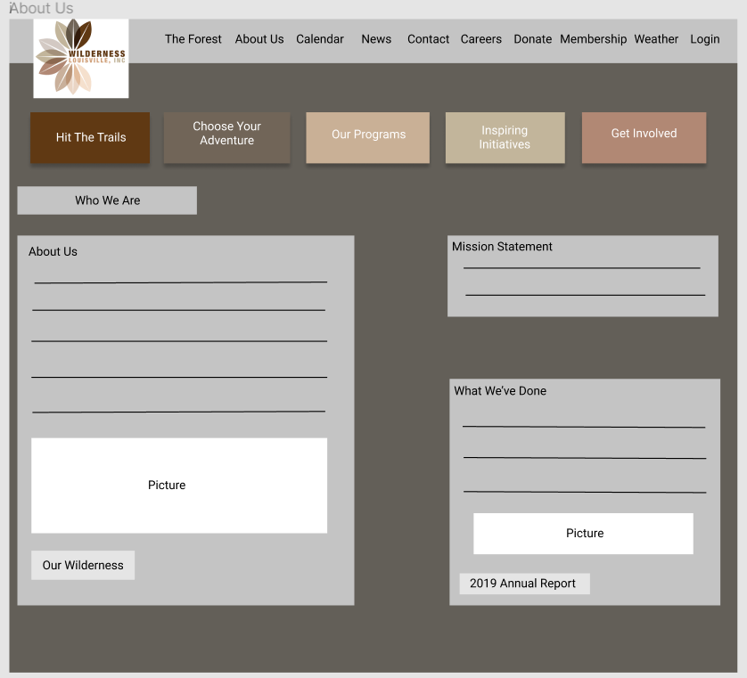

Calendar Page

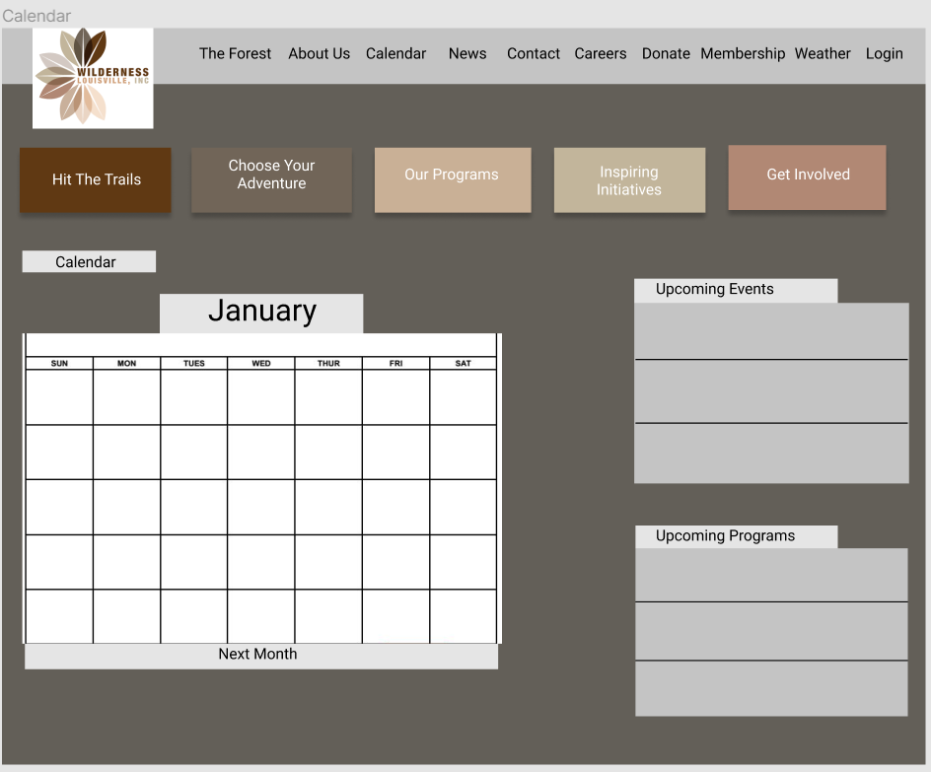

News Page

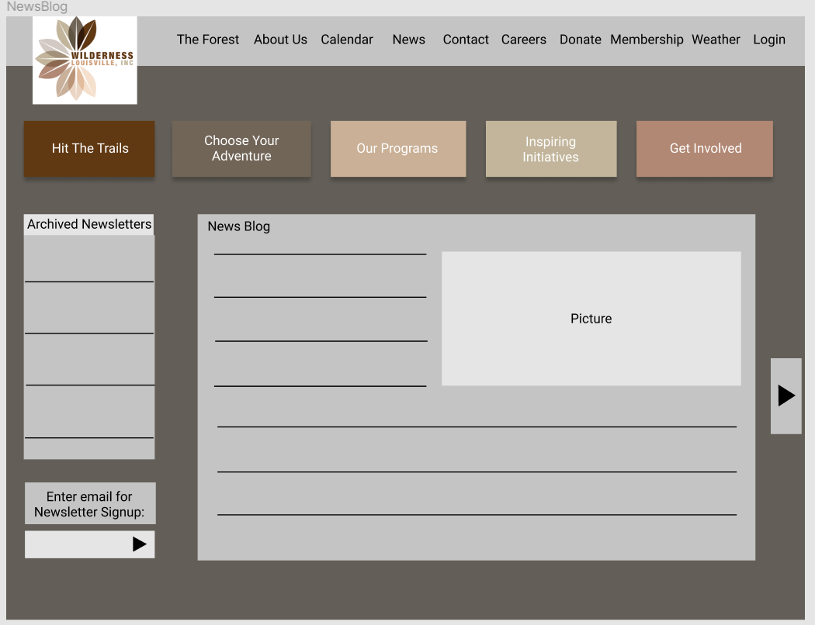

Contacts Page

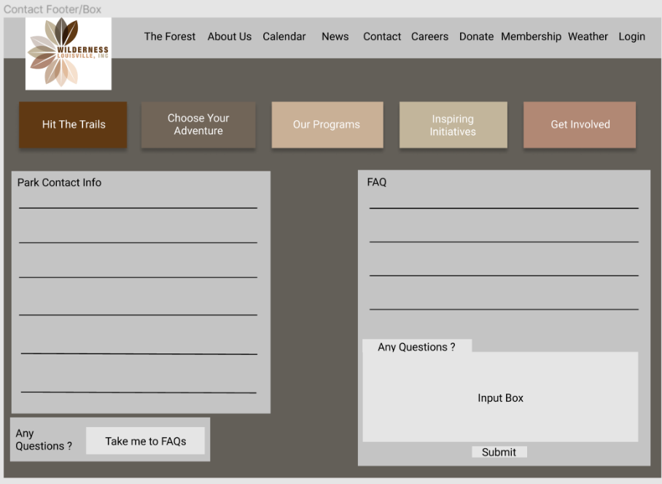

Staff/Board Page

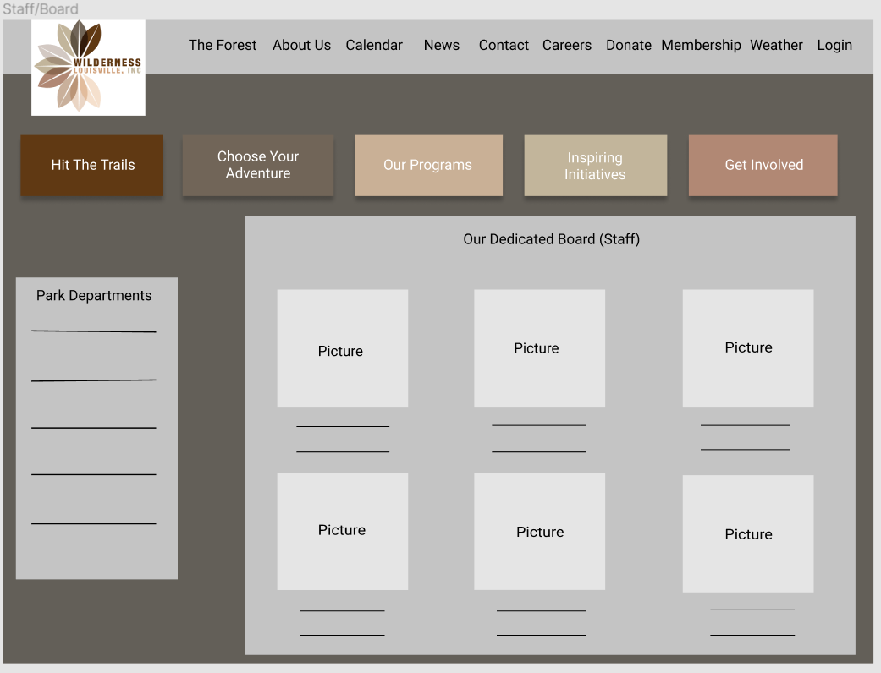

Login Page

Donate Page

Membership Page

Weather Page

Registration and Payment Page

Shop 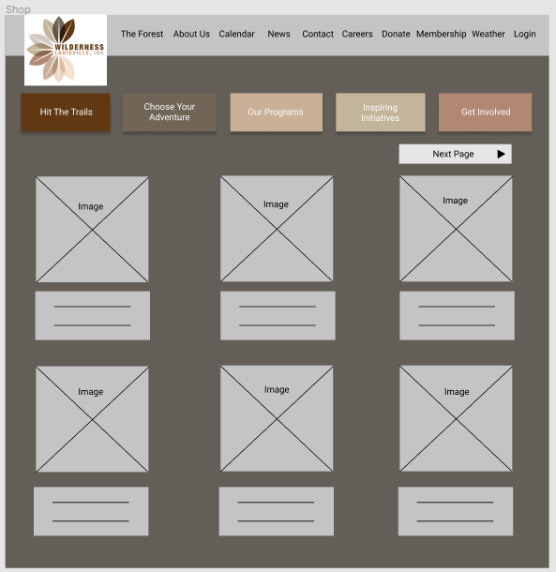

Job Postings 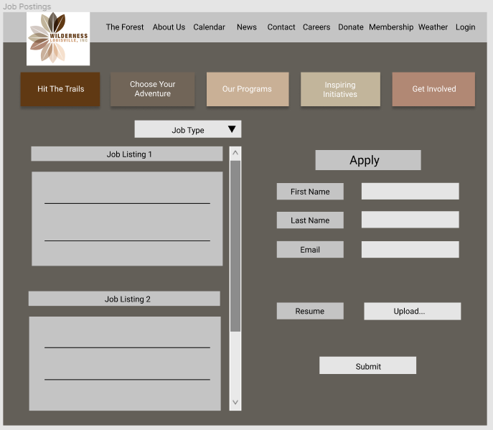

Key initiatives 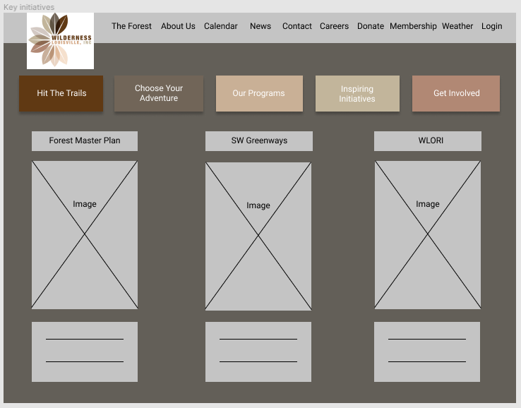

ECHO Programming 